EXPT NO: 5 | AI Game Playing: Implementation of Minimax in Tic-Tac-Toe
DATE: 26.08.2025

PRE-LAB QUESTIONS (Write the answers in your AI and Automation Notebook)
- What is the Minimax algorithm in the context of Artificial Intelligence?
The Minimax algorithm is a decision-making algorithm in AI used for two-player games, aiming to minimize the possible loss for a worst-case opponent strategy.

- How does the Minimax algorithm evaluate the best move in a two-player game like Tic-Tac-Toe?
In Tic-Tac-Toe, Minimax explores all possible moves, simulates outcomes, assigns utility values, and selects the move maximizing the player's chance of winning while minimizing losses.

- What are the roles of the maximizing and minimizing players in Minimax?
The maximizing player aims to achieve the highest possible score, while the minimizing player tries to reduce it, simulating optimal play from both opponents.

- Why is Tic-Tac-Toe considered a zero-sum game?
Tic-Tac-Toe is a zero-sum game because one player's gain equals the other player's loss—total payoff remains constant, making outcomes purely competitive.

- What is the significance of terminal states and utility values in Minimax
Terminal states represent game endings (win, loss, draw), and utility values quantify these results, guiding Minimax in choosing the most favorable move.

IN-LAB EXERCISE
OBJECTIVE:
To implement the Minimax algorithm in a Tic-Tac-Toe game, enabling the computer to play optimally against a human player and never lose.

PROCEDURE:
Game Scenario
- Game Type: Two-player turn-based game (Human vs AI)
- Board: 3x3 grid
- Symbols:
- Human: 'X'
- AI: 'O'
- Goal: Implement Minimax so the AI always chooses the best possible move.
Implementation Steps:
- Represent the Board: Use a 2D array or list to represent the 3x3 grid.
- Define Game Rules:
  - Check for win, loss, or draw.
  - Validate legal moves.
- Implement Minimax Algorithm:
  - Recursively evaluate all possible game states.
  - Assign scores: +1 for AI win, -1 for Human win, 0 for draw.
  - AI chooses the move with the highest score (maximizing).
  - Human is assumed to play optimally (minimizing).
- Integrate with Game Loop:
  - Alternate turns between Human and AI.
  - Display board after each move.
  - End game when win or draw is detected.
- Print Final Result:
- Show winner or declare draw.
- Display move history if required.

SCREENSHOT OF CODE
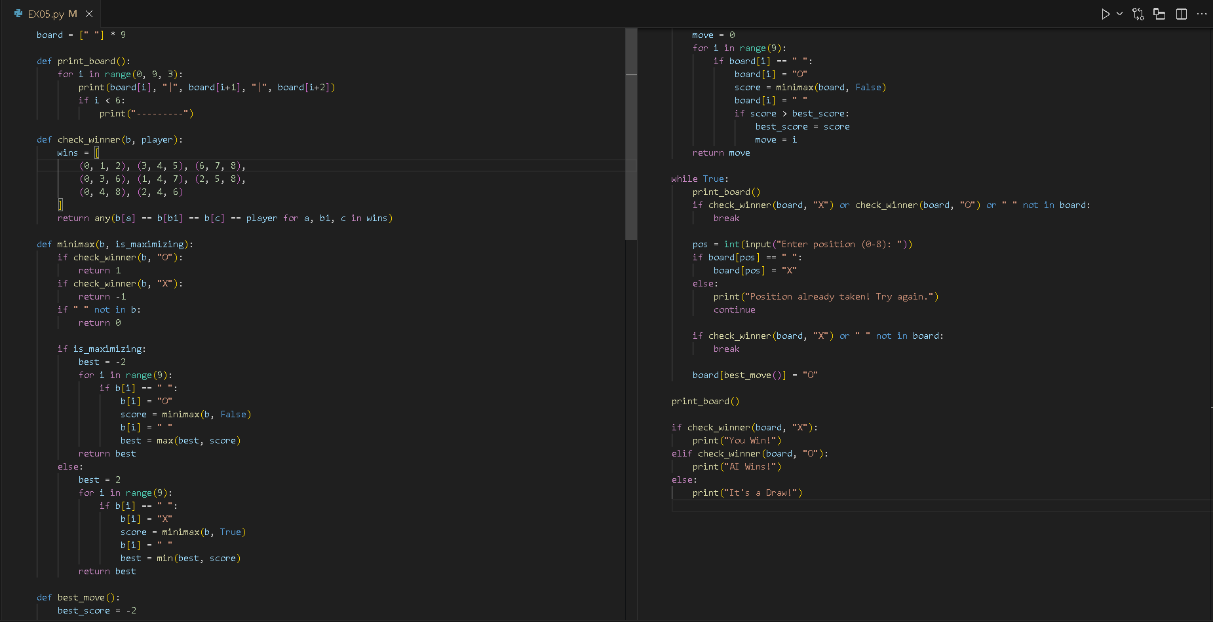

SCREENSHOT OF OUTPUT
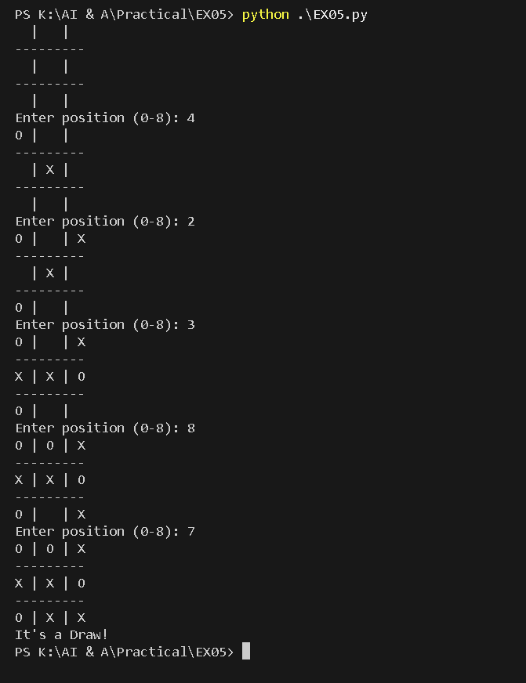

POST-LAB QUESTIONS (Write the answers in your AI and Automation Notebook)

- Why does the AI never lose when using the Minimax algorithm in Tic-Tac-Toe?
The AI never loses because Minimax exhaustively evaluates all possible moves, ensuring it always selects the optimal strategy to win or force a draw.

- What happens if the human player makes a mistake? How does Minimax exploit it?
When the human makes a mistake, Minimax detects the suboptimal move and chooses a response maximizing its advantage, often leading directly to a win.

- How does the depth of recursion affect performance in larger games like Chess or Go?
Increased recursion depth drastically slows performance in complex games like Chess or Go due to exponential growth of possible states requiring pruning techniques.

- If you added randomness to the AI’s move selection when multiple optimal moves exist, how would that affect gameplay?
Adding randomness among equally optimal moves makes gameplay less predictable and more human-like without reducing the AI’s overall strategic effectiveness or strength.

- How could you modify the Minimax algorithm to handle games with non-zero-sum outcomes or probabilistic elements?
To handle non-zero-sum or probabilistic games, Minimax can be modified using Expectiminimax, incorporating chance nodes and probability-based utility calculations for uncertain outcomes.

RESULT:
The Minimax algorithm was successfully implemented to enable an AI player to make optimal decisions in a Tic-Tac-Toe game. The AI consistently selected moves that either led to a win or forced a draw, demonstrating the effectiveness of the algorithm in a zero-sum, turn-based environment.

ASSESSMENT (Write in your lab notebook)
Description | Max Marks | Marks Awarded
Pre Lab Exercise | 5
In Lab Exercise | 10
Post Lab Exercise | 5
Viva | 10
Total | 30
Faculty Signature

